**SCM AR REPORT DOC**

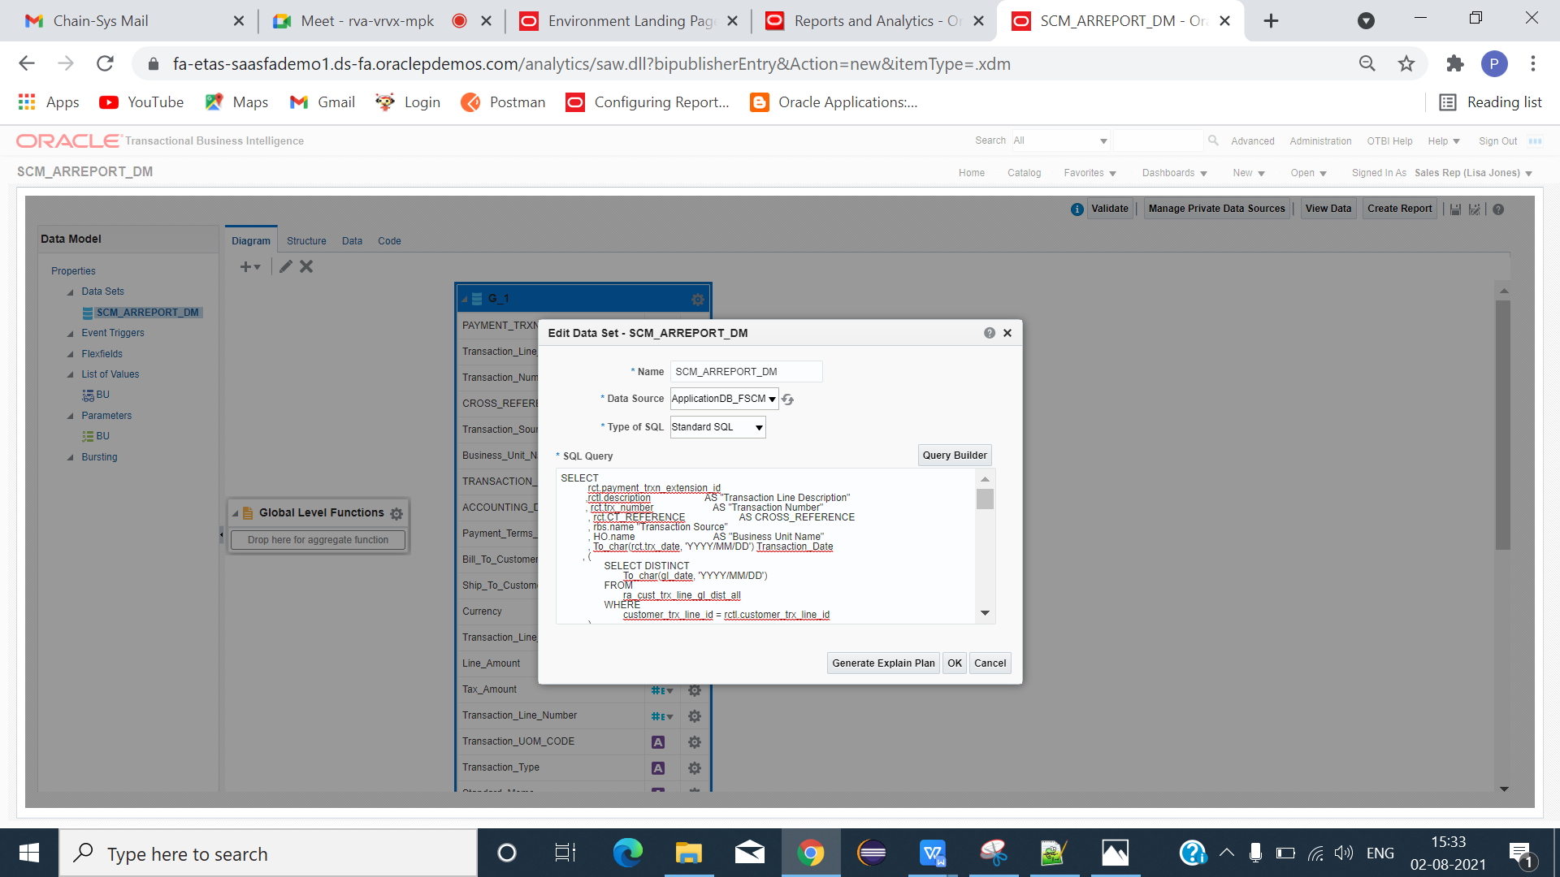

CLICK -> NEW -> DATAMODEL.

TYPE AP AGING QUERY.

**DATA MODEL QUERY**

SELECT

rct.payment_trxn_extension_id

,rctl.description AS "Transaction Line Description"

, rct.trx_number AS "Transaction Number"

, rct.CT_REFERENCE AS CROSS_REFERENCE

, rbs.name "Transaction Source"

, HO.name AS "Business Unit Name"

, To_char(rct.trx_date, 'YYYY/MM/DD') Transaction_Date

, (

SELECT DISTINCT

To_char(gl_date, 'YYYY/MM/DD')

FROM

ra_cust_trx_line_gl_dist_all

WHERE

customer_trx_line_id = rctl.customer_trx_line_id

)

AS Accounting_Date

, (

SELECT

name

FROM

ra_terms

WHERE

term_id = rct.term_id

)

AS "Payment Terms Name"

, (

SELECT DISTINCT

account_number

FROM

hz_cust_accounts

WHERE

cust_account_id = rct.bill_to_customer_id

)

AS "Bill_To_Customer_Account"

, (

SELECT DISTINCT

account_number

FROM

hz_cust_accounts

WHERE

Party_id = rct.Ship_to_party_id

)

AS "Ship_To_Customer_Account"

,rct.invoice_currency_code AS "Currency"

, rctl.line_type AS "Transaction Line Type"

, Decode (rctl.line_type, 'LINE', rctl.extended_amount, NULL) AS "Line Amount"

, Decode (rctl.line_type, 'TAX', rctl.extended_amount, NULL) AS "Tax Amount"

, rctl.line_number AS "Transaction Line Number"

, rctl.UOM_CODE "Transaction UOM CODE"

, rctta.Name "Transaction Type"

, amlat.Name "Standard Memo"

, rct.attribute1

, rct.attribute3

, rct.attribute5

, rct.attribute6

, rct.attribute7

, (

SELECT

tax_rate_code

FROM

zx_lines

WHERE

tax_line_id = rctl.tax_line_id

)

AS "Tax Rate Code"

,RCTL.CUSTOMER_TRX_LINE_ID

,rctl.interface_line_context

, rctl.interface_line_attribute1

, rctl.interface_line_attribute2

, baa.bank_name

, baa.bank_branch_name

, Nvl(BAA.bank_account_name, BAA.primary_acct_owner_name) bank_account_name

, baa.bank_account_number

, rm.name receipt_method_name

,rctl.source_document_line_number

,rct.created_by AS "Created By"

FROM

ra_customer_trx_all rct

, ra_customer_trx_lines_all rctl

, ra_batch_sources_all rbs

, hr_operating_units HO

, RA_CUST_TRX_TYPES_ALL rctta

, ar_memo_lines_all_b amlab

, ar_memo_lines_all_tl amlat

, iby_ext_bank_accounts_v BAA

, iby_pmt_instr_uses_all BAUA

, ar_receipt_methods rm

, iby_fndcpt_tx_extensions fte

WHERE

rct.customer_trx_id = rctl.customer_trx_id

AND rct.batch_source_seq_id = rbs.batch_source_seq_id

AND RCT.org_id = RCTL.org_id

AND rct.org_id = HO.organization_id

AND HO.name = NVL( :BU,HO.name)

AND rct.payment_trxn_extension_id = fte.trxn_extension_id (+)

AND rct.receipt_method_id = rm.receipt_method_id(+)

AND fte.instr_assignment_id = BAUA.instrument_payment_use_id (+)

AND rct.CUST_TRX_TYPE_SEQ_ID = rctta.CUST_TRX_TYPE_SEQ_ID

AND amlab.memo_line_id = amlat.memo_line_id (+)

and rctl.memo_line_seq_id =amlab.memo_line_seq_id (+)

and amlat.LANGUAGE (+) = 'US'

AND baua.payment_function (+) = 'CUSTOMER_PAYMENT'

AND Trunc(SYSDATE) BETWEEN Nvl(BAUA.start_date, SYSDATE - 1) AND Nvl(BAUA.end_date, SYSDATE + 1)

AND baa.ext_bank_account_id (+) = baua.instrument_id

**PARAMETERS**

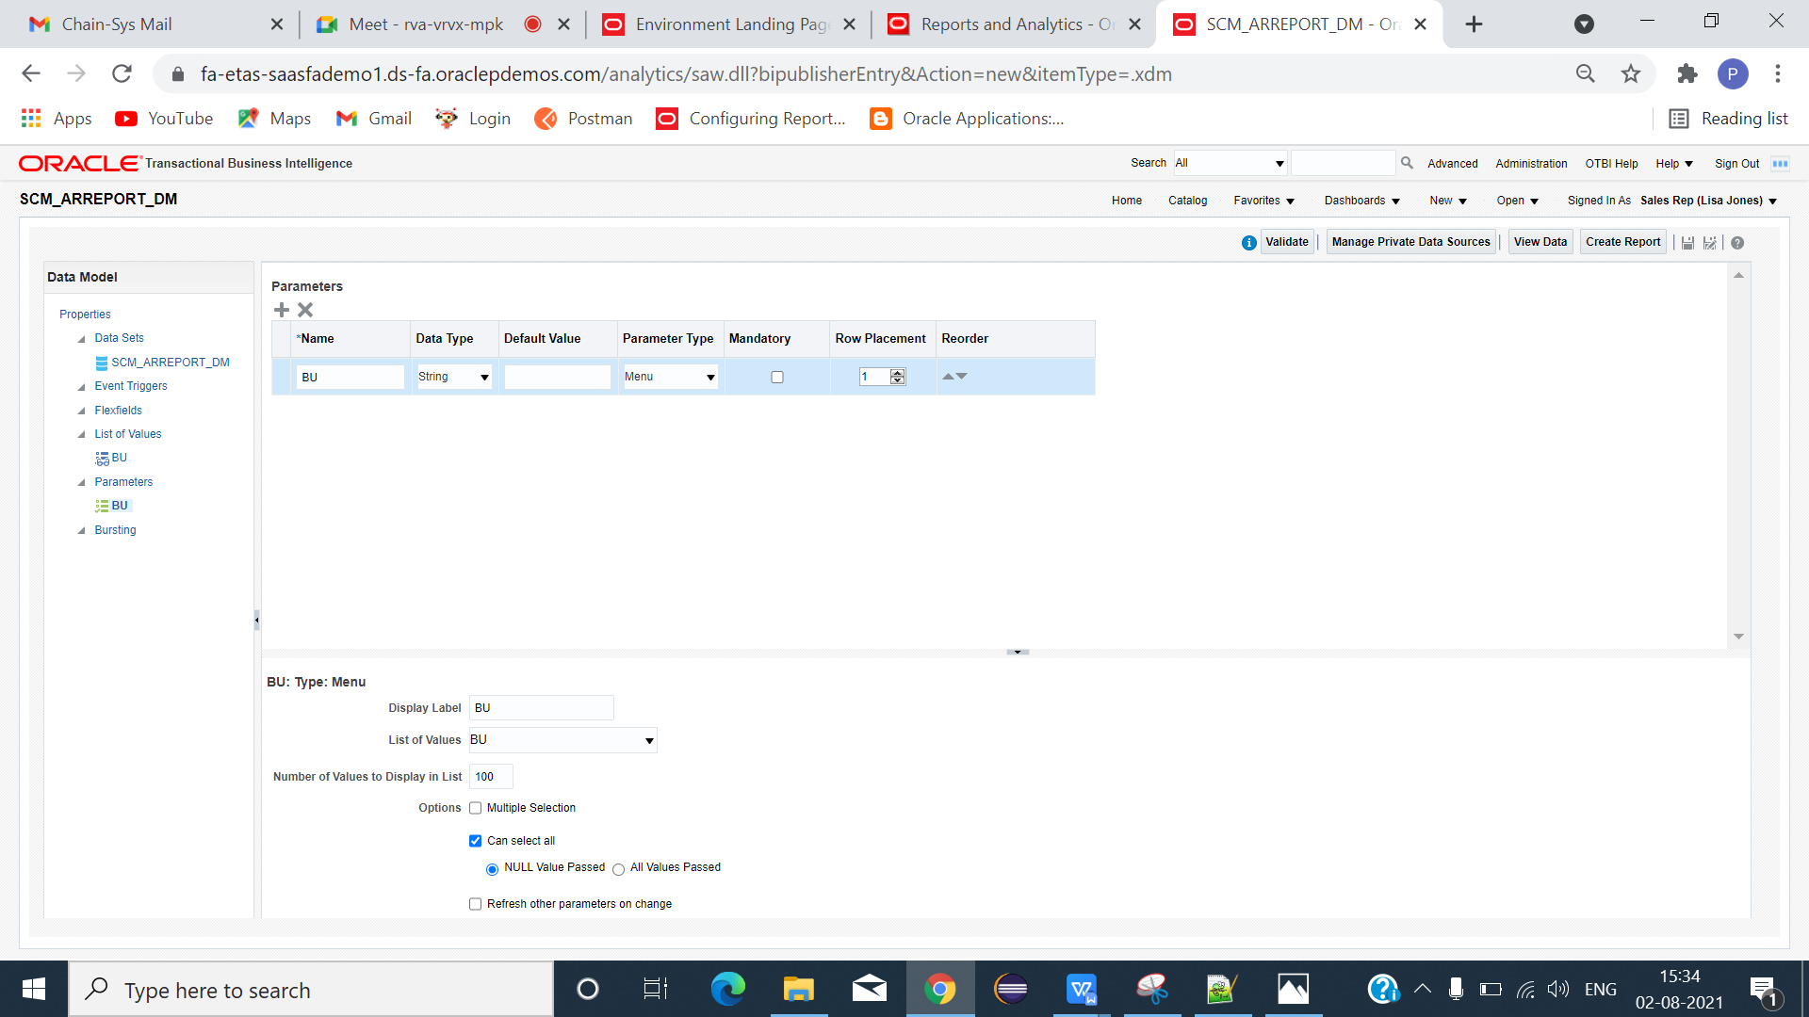

**LIST OF VALUES QUERY**

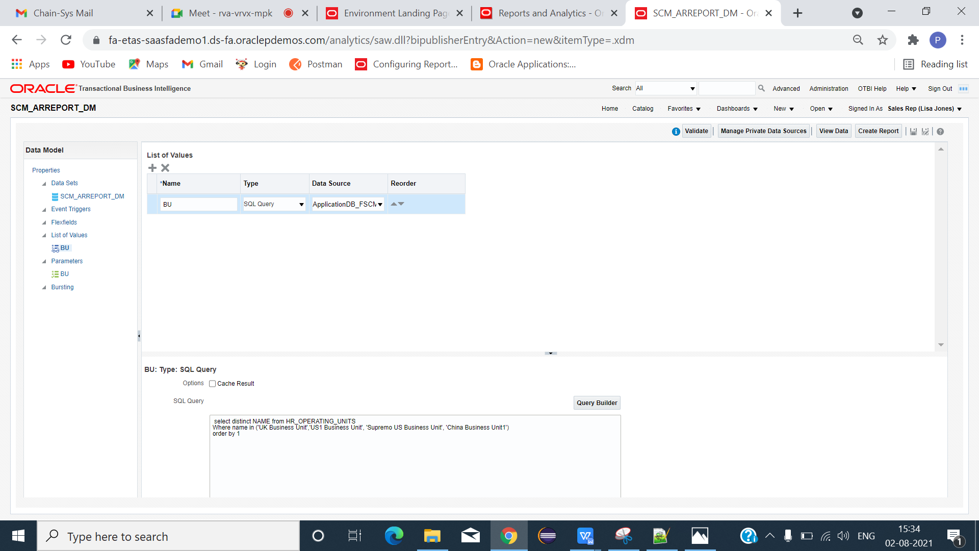

**BU:**

select distinct NAME from HR_OPERATING_UNITS

Where name in ('UK Business Unit','US1 Business Unit', 'Supremo US Business Unit', 'China Business Unit1')

order by 1

CLICK DATA -> SAVE -> VIEW -> VIEW SAMPLE DATA -> SAVE -> EXPORT(XML FILE).

**EXCEL TEMPLATE**

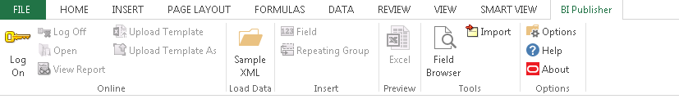

CLICK SAMPLE XML(LOAD DATA) - > LOAD XML FILE -> FIELD(META DATA CREATED) .

INSERT COLUMNS USING FIELDS(PARAMETER AND REQUIRED COLUMNS).



SAVE TEMPLATE AS (EXCEL 2003 WORKBOOK) FORMAT.

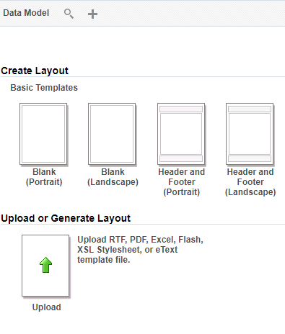

LOAD DATA MODE -> CLICK UPLOAD OR GENERATE LAYOUT.

GIVE LAYOUT NAME -> LOAD TEMPLATE -> CHOOSE TEMPLATE FORMAT -> LOCALE -> OK

SAVE -> REPORT -> RUN

REPORT SUCCESSFULLY GENERATED IN EXCEL FORMAT.

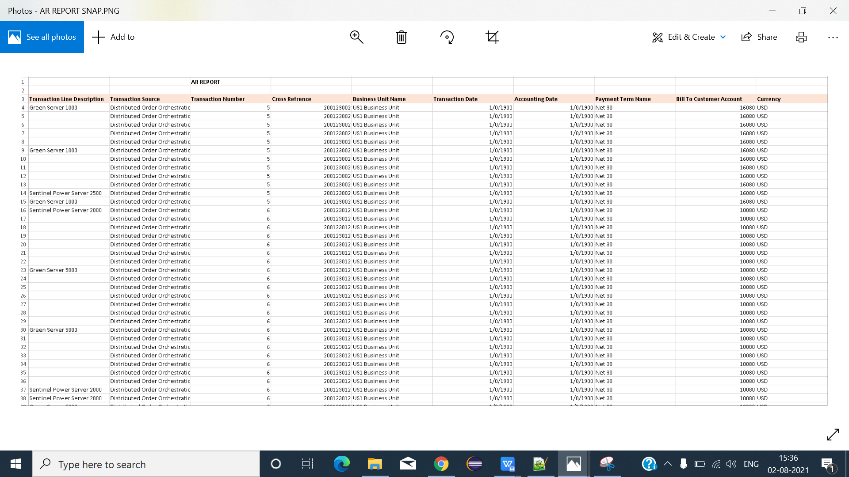

FINAL OUTPUT RESULT IN EXCEL FORMAT.

===================================================================================